PROJECT DESIGN PHASE
Problem – Solution Fit Template

Date | 2 November 2025
Team ID | NM2025TMID08137
Project Name | Educational Organisation Using ServiceNow
Maximum Marks | 2 Marks

Problem – Solution Fit Template

The Problem–Solution Fit highlights how the project identifies a genuine challenge faced by educational institutions and develops a practical solution that effectively addresses it. In this project, the focus is on digitizing and automating administrative and academic operations within an educational organization using the ServiceNow platform.

Purpose:

❑ To automate routine administrative activities such as admissions, student data management, and faculty information handling through ServiceNow.
❑ To enhance communication and coordination among departments by introducing a unified digital platform.
❑ To reduce manual errors and processing delays through automated workflows and instant data access.
❑ To improve transparency and academic performance monitoring using digital forms, reports, and dashboards.
❑ To develop a scalable, flexible ServiceNow-based management solution adaptable to any educational institution’s needs.
Template:
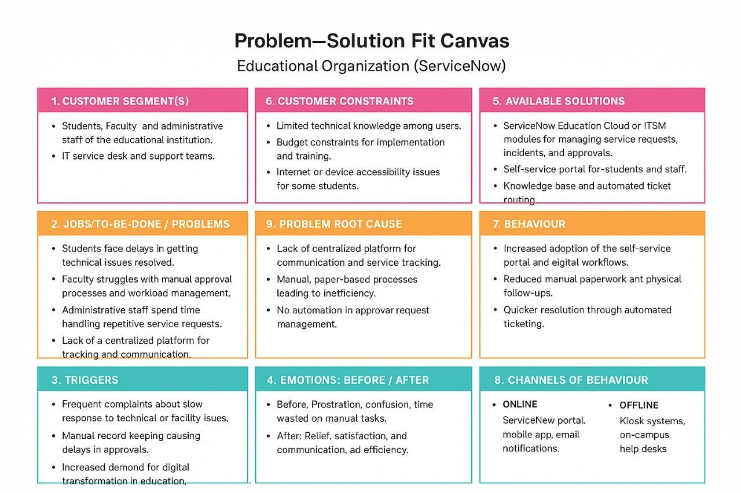

The project “Educational Organization Management System Using ServiceNow” aims to resolve the increasing challenges of manual processes, fragmented data handling, and communication inefficiencies within educational institutions.
Currently, many organizations rely on paper-based or semi-digital systems to manage student and faculty information, admissions, and performance tracking — leading to inconsistency, redundancy, and reduced operational efficiency.
This project introduces a ServiceNow-based Educational Management System that centralizes all academic and administrative functions. The platform enables seamless automation of workflows, including form design, record maintenance, approval routing, and data tracking, ensuring that every institutional process runs smoothly and accurately.
By integrating automation and real-time data management, the solution enhances data accuracy, operational speed, and user satisfaction. It fosters better interdepartmental coordination, eliminates repetitive manual tasks, and supports data-driven decision-making.
Through this ServiceNow implementation, educational institutions can transition into a smart, digitally empowered environment—boosting efficiency, transparency, and overall productivity across all levels of management.

